DEPARTMENT OF MATHEMATICAL AND COMPUTATIONAL SCIENCES
NATIONAL INSTITUTE OF TECHNOLOGY KARNATAKA, SURATHKAL
MA611 – 2nd Semester MCA, 2024-2025
DATABASE SYSTEMS LAB
Assignment-5
1. Create the following tables with the following attributes and constraints on them.
a. Bank (bk_code, bk_name, bk_address)
b. Branch (br_id, br_name, br_address, bk_code)
c. Customer (cust_ID, cust_name, phone_no, address)
d. Account (acc_no, acc_type, balance, br_id)
e. Customer_Account (cust_ID, acc_no)
f. Loan (loan_ID, loan_type, amount, br_id)
g. Customer_Loan (cust_ID, loan_ID)
1. Create all the tables by defining primary key, foreign key and other appropriate constraints.
2. Insert atleast five records in each table.
3. List the details of all customers.
4. Find the cust_ID and phone number of customer ‘Ravi’.
5. Find the Address of all branches of br_01.
6. Find the details of Customer having ID 103.
7. List the account details having balance more than 10000.
8. List the account details of branch br_02.
9. List the loan details of branch br_01.
10. List the account details with their branch address.
11. List the customer details with their account details.
12. List the customer details having account type ‘savings’.
13. List the customer details having vehicle loan.
14. List the branch names of all accounts.
15. List the customer details going to ‘Surathkal’ branch.
16. List the customers having loan account in ‘MG Road’ branch.

select c.cust_ID, c.cust_name, c.phone_no, c. address, b.br_name from
2 Branch b join Account a on b.br_id= a.br_id join Customer_Account ca on a.acc_no=ca.acc_no join Customer c on c.cust_ID= ca.cust_ID where b.br_name='MG Road Branch';

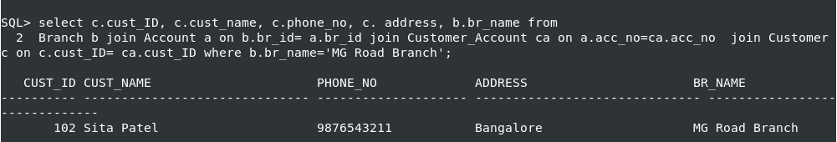

17. Find the customers having balance between 1000 to 10000 .

SQL> select c.cust_ID, c.cust_name, c.phone_no, c.address, a.balance from
2 Customer c join Customer_Account ca on c.cust_ID= ca.cust_ID join Account a on a.acc_no= ca.acc_no where a.balance>1000 and a.balance<10000;
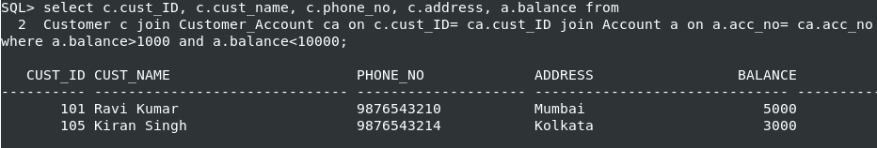

18. Give a bonus of rupees 100 to customers having more than 10000 balance.

SQL> update account set balance=balance+100
2 where balance>10000;

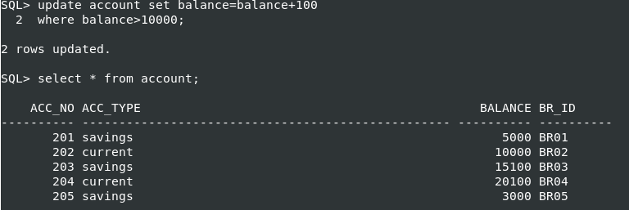

19. Deduct 50 rupees from customers having less than 500 rupees in balance.

SQL> update account set balance=balance-50
2 where balance<500;

20. Give the customer details having home loan.

SQL> select c.cust_ID, c.cust_name, c.phone_no, c.address, l.loan_type
from Loan l join Customer_Loan cl on l.loan_ID= cl.loan_ID join Customer c on c.cust_ID= cl.cust_ID
where l.loan_type=’Home Loan’;
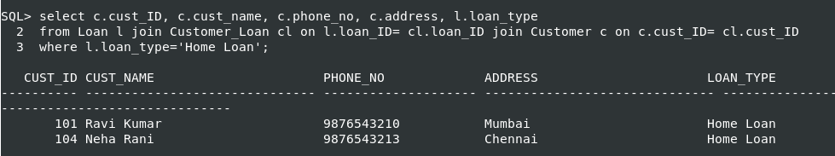

21. Give the customer details having vehicle loan in ‘NITK’ branch.

SQL> select c.cust_ID, c.cust_name, c.phone_no, c.address
2 from Loan l join Branch b on b.br_id= l.br_id join Customer_Loan cl on l.loan_ID=cl.loan_ID join Customer c on c.cust_ID= cl.cust_ID where b.br_name='NITK Branch' and l.loan_type='Vehicle Loan';

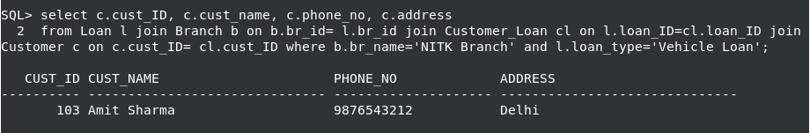

22. Add a column NOMINEE to the customer table with data type varchar (50).

SQL> alter table Customer
2 add NOMINEE varchar(50);

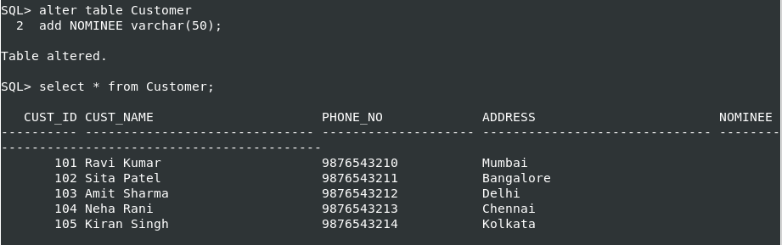
23. List all the account numbers in ascending order of their balance.

SQL> select * from account
2 order by balance;

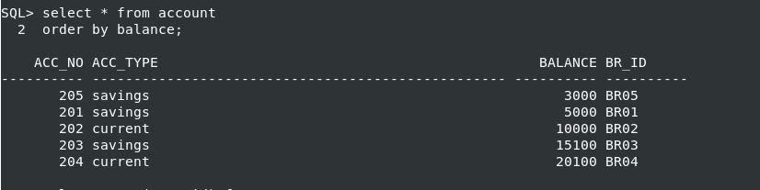
24. Count the number of customers having account type savings.

SQL> select count(acc_no) from Account where acc_type='savings';

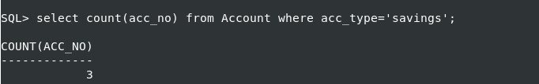

25. Count the number of customers for each account type.

SQL> select acc_type, count(acc_no) as Number_of_Accounts
2 from account group by acc_type;

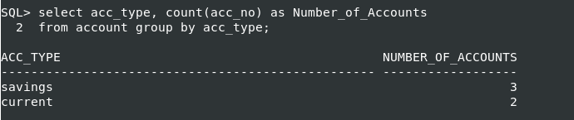
26. Find the total balance in Savings account.

SQL> select acc_type, sum(balance) as Total_Balance
2 from account where acc_type='savings'
3 group by acc_type;

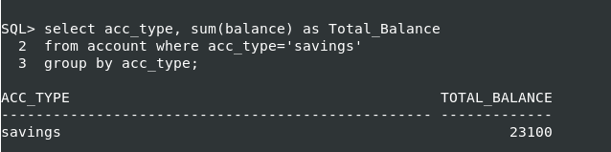

27. Find the average balance of Current account.

SQL> select acc_type, avg(balance) as Average_balance
2 from account where acc_type='current'
3 group by acc_type;

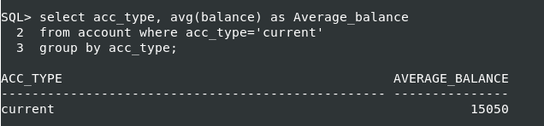

28. Find the average balance for each account type.

SQL> select acc_type, avg(balance) as Average_balance
2 from account
3 group by acc_type;

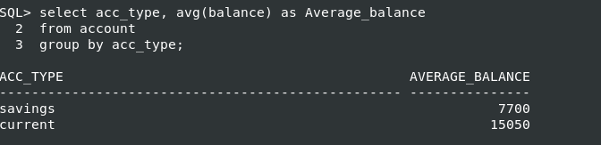
29. Find the customer details having maximum balance.

SQL> select c.cust_ID, c.cust_name, c.phone_no, c.address, a.balance
2 from Account a join Customer_account ca on a.acc_no=ca.acc_no
3 join Customer c on c.cust_ID= ca.cust_ID where a.balance =(select max(balance) from account);
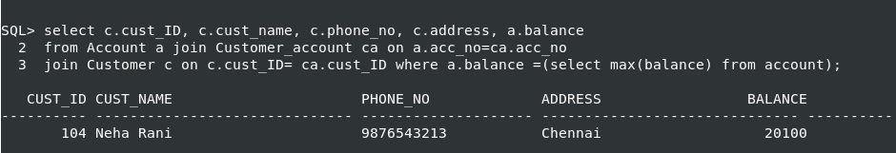
30. Find the average amount for vehicle loan.

SQL> select loan_type, avg(amount) as Average_loan from loan
2 where loan_type='Vehicle Loan'
3 group by loan_type;

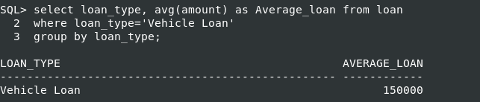
31. Find the average balance in each branch.
SQL> select b.br_name as Branch_Name, avg(a.balance) from Branch b join Account a on a.br_id=b.br_id
2 group by b.br_name;
